# Western Indian Ocean Regional Ocean GovernanceUnited Nations Logo and symbol, meaning, history, PNG, brand

# **Consultancy to Provide Technical Services and Facilitate Stakeholder Engagement in the Development of Participatory, Evidence-Based Marine Spatial Planning and Related Management Plans in Mkuranga and Mkoani-Pemba**

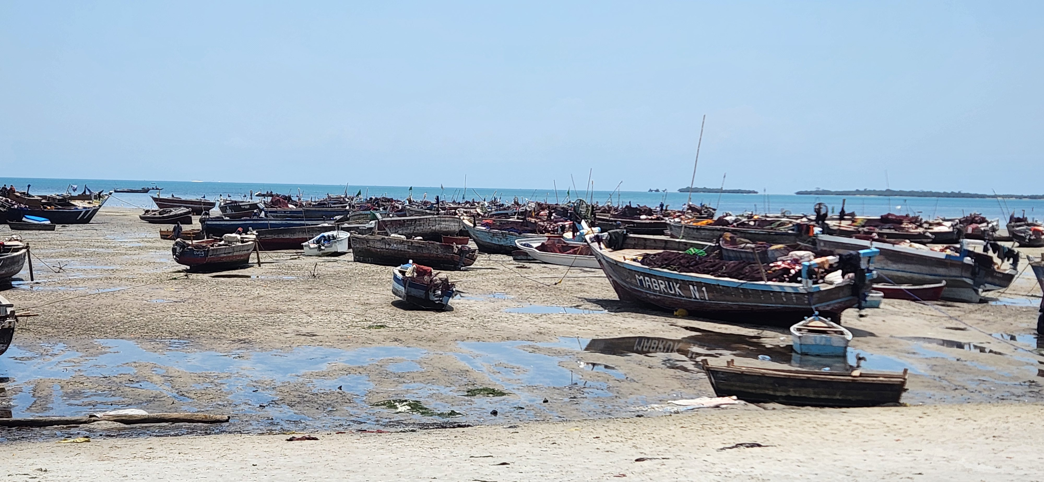**INCEPTION REPORT**

Submitted to:

United Nations Office at Nairobi (UNON)

Gigiri Complex, W Block, Level 3, West Wing

Prepared By:

Siajali Pamba Zegge (Lead Consultancy)

University of Dar Es Salaam

P.O.Box 60091,

Dar es Salaam, Tanzania

**September 2025**

# 

Consultancy to Provide Technical Services and Facilitate Stakeholder Engagement in the Development of Participatory, Evidence-Based Marine Spatial Planning and Related Management Plans in Mkuranga and Mkoani-Pemba

**INCEPTION REPORT**

# 

# EXECUTIVE SUMMARY

# This Inception Report details the methodology, work plan, and deliverables for the six-month project, "Developing Participatory, Evidence-Based Marine Spatial Planning for Mkuranga and Mkoani Districts, Tanzania," running from September 15, 2025, to February 23, 2026. The project addresses the increasing pressures on the vital marine ecosystems of the Mkuranga and Mkoani districts, which threaten local livelihoods and biodiversity, by establishing a comprehensive evidence base to support future MSP processes.

# The project will employ a rapid, integrated methodology focused on intensive data collection, participatory mapping with local communities, and detailed economic analysis. This approach will generate data and information on historical biodiversity trends, current resource use, and the economic value of marine and coastal ecosystems in the project areas. The work involves mapping of biodiversity, identifying and zoning areas of biodiversity loss or gain, analysing spatial overlaps and ecological trade-offs between marine uses, and validating all findings through extensive stakeholder engagement.

# LIST OF ABBREVIATIONS

|  |  |
| --- | --- |
| **Abbreviation** |  |
| BMU | Beach Management Unit |
| CFMAs | Collaborative Fisheries Management Areas |
| EO | Earth Observation |
| FAO | Food and Agriculture Organization of the United Nations |
| IMS | Institute of Marine Sciences |
| IPCC | Intergovernmental Panel on Climate Change |
| IUU | Illegal, Unreported and Unregulated |
| MPRA | Marine Parks and Reserve Units |
| MSP | Marine Spatial Planning |
| NBS | National Bureau of Statistics |
| NEMC | National Environmental Management Council |
| NGOs | Non- Non-Governmental Organization |
| OBIS | Ocean, Biodiversity Information System |
| RoGZ | Revolutionary Government of Zanzibar |
| SUZA | State University of Zanzibar |
| TAFIRI | Tanzania Fisheries Research Institute |
| TNC | The Nature Conservancy |
| UDSM | University of Dar es Salaam |
| UNEP | United nations Environment Programme |
| URT | United Republic of Tanzania |
| WIOMSA | Western Indian Ocean Marine Science Association |
| WPs | Work packages |
| WWF | World Wide Fund for Nature |
| ZAFIRI | Zanzibar Fisheries Research Institute |

**TABLE OF CONTENTS**

LIST OF ABBREVIATIONS ii

TABLE OF CONTENTS iii

LIST OF TABLES v

LIST OF FIGURES vi

1.0 INTRODUCTION 1

1.1 Background and Context 1

1.2 Objectives of the Project 2

1.3 Scope of Work 3

1.3.1 Geographical Scope 3

1.3.2 Methodological Scope 4

1.3.3 Thematic Scope 4

1.4 Limitation 4

1.5 Structure of the Report 5

2.0 METHODOLOGY AND APPROACHES 6

2.1 WP1: Data Requirements 6

2.1.1 Secondary Data Collection 6

2.1.2 Primary Data Collection 6

2.2 WP2: Project Inception and Stakeholder Engagement 7

2.2.1 Stakeholder Engagement 8

*2.2.1.1 Key Stakeholder Groups* 8

2.4: WP4: Economic Valuation and Feasibility Analysis 11

2.4.1 Classify and catalog coastal and marine assets 11

2.4.2 Conduct an ecosystem services analysis through a comparative risk assessment of the ecosystems. 11

2.4.3 Conduct a baseline ecosystem services valuation, quantifying the revenue generated 12

2.4.4 Conduct a cost-benefit analysis to evaluate the benefits of implementing proposed bioeconomic activities and the costs of implementation. 14

2.4.5 Propose green/blue finance instruments for funding of the management plan and implementation of proposed bio-economic activities 14

2.4.6 Recommend further policy measures and management interventions 15

2.5 Synthesis and Digital Dissemination 16

3.0 KEY DELIVERABLES, DEADLINES, ETHICAL CONSIDERATIONS AND TEAM COMPOSITION 17

3.1 Key Deliverables and Deadlines 17

3.2 Ethical Considerations 17

3.3 Team composition and Responsibilities 18

4.0 RISKS AND MITIGATION MEASURES 20

4.1 Mitigation Measures 21

ANNEX 1: Detailed Work Schedule Aligned With Project Timelines 22

ANNEX 2: Stakeholder Analysis Report 23

ANNEX 3: Term of References 26

**LIST OF TABLES**

Table 2.1: Data requirements for Main activities 7

Table 2.2 Proposed stakeholder engagement plan 10

Table 2.3: The Components of Risks and their Indicator 12

Table 4.1: Expected risks 19

**LIST OF FIGURES**

Figure 1.1: The maps showing the location of the project area 3

# 1.0 INTRODUCTION

# 1.1 Background and Context

Tanzania's marine and coastal ecosystems are essential to the country's development, biodiversity preservation, and climate resilience (UNEP, 2020; URT, 2022). Mangroves, seagrass beds, coral reefs, beaches, and estuaries are among the varied habitats found along the nation's 1,400 km coastline (Richmond, 2011; Mgaya, 2016; NEMC, 2024). These ecosystems provide vital services, including tourism, carbon sequestration, shoreline protection, and food security (FAO, 2022; UNEP, 2019). Coral reefs covering approximately 3,500 km² host fish species vital for both artisanal and commercial fisheries (Maina et al., 2016; UNEP, 2020; NEMC, 2024). Mangrove forests, estimated at 115,000 hectares, stabilize shorelines, provide wood and non-timber products, and serve as globally significant carbon sinks (URT, 2022; WIOMSA, 2018, RoGZ. 2023). Seagrass meadows play a crucial role as nursery grounds for fish and invertebrates, as well as supporting endangered species such as turtles and dugongs (Richmond, 2011; Obura et al., 2019; NEMC, 2024). The ecological health of these habitats underpins the livelihoods of millions of Tanzanians while contributing to regional food security and climate resilience (Mgaya, 2016; FAO, 2022).

Additionally, Tanzania's economy depends heavily on its marine and coastal resources. Over 90 per cent of the nation's fish consumption comes from fisheries, which also provide jobs for over 200,000 people (FAO, 2022; NEMC, 2024). Mostly carried out by women in Zanzibar and along the southern coast, seaweed farming generates a substantial income and promotes gender equality (WIOMSA, 2018; RoGZ, 2023). Employment opportunities and foreign exchange are produced by tourism, especially by marine-based tourism in places like Pemba, Mafia, and Zanzibar (UNEP, 2019; RoGZ, 2023; NEMC, 2024). Furthermore, seagrasses and mangroves provide ecosystem services that can be capitalized on by new blue carbon markets (UNFCCC, 2015; URT, 2021). A key component of Tanzania's blue economy agenda is taking advantage of these opportunities (RoGZ, 2023).

Despite their immense value, these ecosystems face mounting threats. Overfishing and illegal, unreported, and unregulated (IUU) fishing continue to deplete fish stocks (WIOFish Database, 2020). Destructive fishing practices and unsustainable coastal development contribute to habitat degradation (Mgaya, 2016; NEMC, 2024). Pollution from plastics, untreated sewage, and industrial effluents further undermines ecosystem health (UNEP, 2019). Climate change exacerbates these challenges, driving sea-level rise, ocean acidification, and coral bleaching, which compromise ecosystem resilience (IPCC, 2021; Maina et al., 2016). Expanding coastal infrastructure and oil and gas exploration add new risks. Collectively, these pressures erode ecosystem resilience and disproportionately affect vulnerable coastal communities that depend directly on natural resources for their livelihoods (UNEP, 2020; Obura et al., 2019).

Given the importance of coastal and marine ecosystems in the Western Indian Ocean (WIO) region, the United Nations Environment Programme (UNEP), through the Nairobi Convention and its partners, is funding a consultancy to address these challenges by establishing a framework for integrated, ecosystem-based management of marine and coastal resources. A key challenge is the lack of a consolidated evidence base that identifies major marine uses, spatial overlaps, ecological trade-offs, and potential conflicts. This project will directly address this gap by generating the necessary data to inform balanced and sustainable decision-making. This project is both timely and necessary. It directly supports Tanzania's national ambition to develop a sustainable Blue Economy by providing a practical framework for balancing economic development with environmental conservation at the local level.

By focusing on Mkuranga and Mkoani districts, the project aligns with Tanzania's policy of Decentralization by Devolution, empowering local government authorities to manage their natural resources more effectively. Furthermore, the project serves as a tangible implementation of Tanzania's commitments under the Nairobi Convention and its partnership with the SWIOFC. It will generate valuable lessons and a scalable model for applying MSP in other parts of the country and the wider Western Indian Ocean region, thereby contributing to regional goals for sustainable ocean governance.

**1.2 Objectives of the Project**

The overall goal of this consultancy is to enhance the sustainable management and conservation of marine and coastal ecosystems in Mkuranga and Mkoani districts through the development of a participatory and evidence-based Marine Spatial Plan.

The objectives of the project include:

1. To compile, analyse and synthesize the best available ecological, biological (biodiversity, ecosystem) assets, and human use activities data and information.
2. To produce a comprehensive evidence base of biodiversity, resource use conflict, and climate vulnerability hotspots.
3. Undertake economic valuation of marine ecosystem goods and services.
4. Conduct cost-benefit analysis of proposed interventions and recommend blue/green finance options.
5. Develop an interactive Web Application for communication, data exploration and strategic planning.

**1.3 Scope of Work**

**1.3.1 Geographical Scope**

The consultancy will focus on two priority districts: Mkuranga (mainland Tanzania) which has a coastline of around 90 km of coastline with diverse ecosystems including mangroves, seagrass meadows, coral reefs, estuaries, and sandy beaches, and Mkoani (Pemba, Zanzibar) which is characterized by extensive coral reef systems, productive seagrass beds, mangroves, and small islands and islets (Figure 1.1).

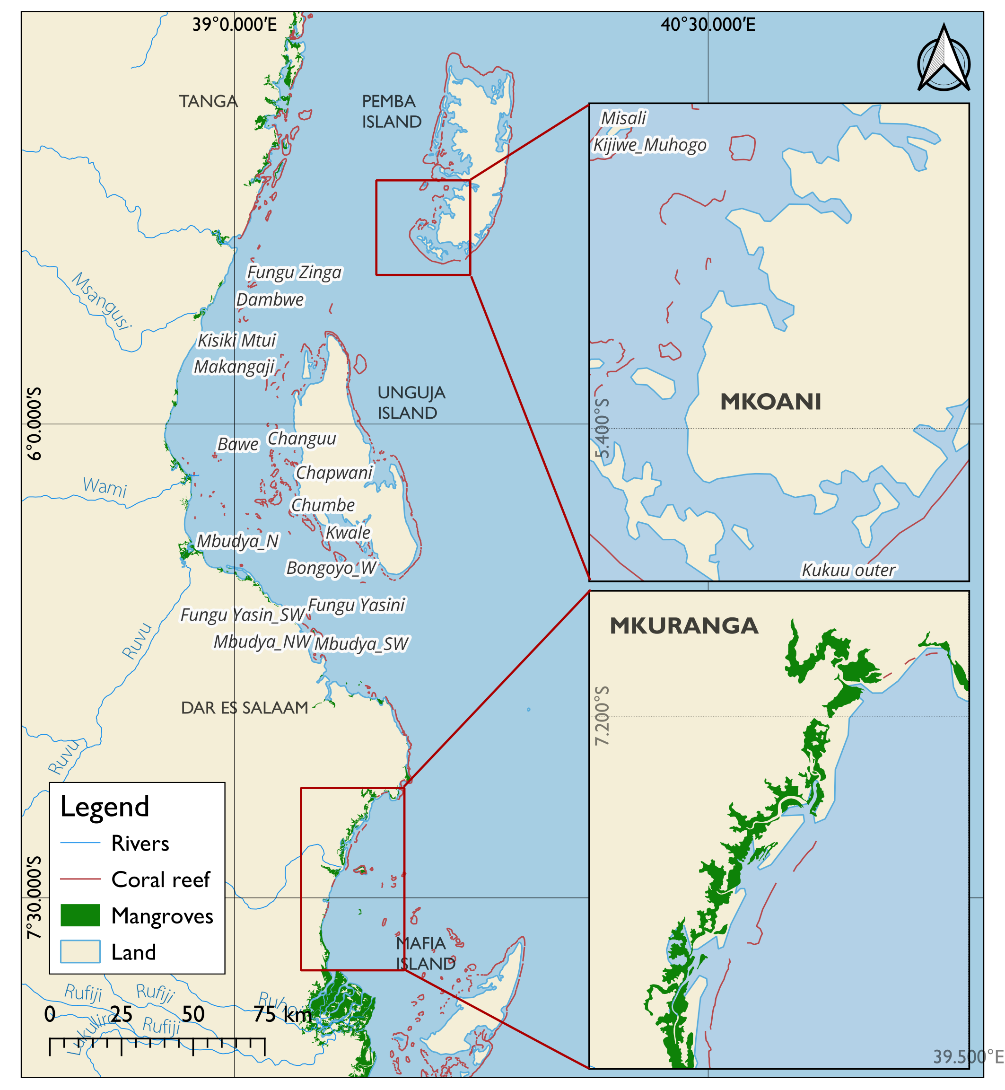

Figure 1.1: The maps showing the location of the project area

**1.3.2 Methodological Scope**

The consultant will employ a mixed-methods approach, integrating spatial analysis, economic valuation, and participatory stakeholder engagement, to ensure that outputs are both scientifically robust and socially relevant. Geospatial mapping and analysis will utilize GIS and remote sensing to generate maps of biodiversity loss and gain trends, identify degraded hotspots, and overlay physical, ecological, and human activity layers. These outputs will be validated through ground-truthing and participatory processes, incorporating local ecological knowledge via workshops, participatory GIS, and focus group discussions. Ecosystem services valuation will be undertaken using comparative risk analysis, market pricing, benefit transfer, and production function approaches to quantify provisioning, regulating, and cultural services in economic terms. In parallel, a cost–benefit analysis will evaluate proposed bioeconomic interventions, such as marine protected areas, octopus closures, seaweed farming, and carbon offset initiatives, to assess their economic viability and sustainability. Ultimately, all spatial and economic data will be consolidated into an interactive, web-based dashboard, providing a practical decision-support platform for stakeholders at both local and national levels.

**1.3.3 Thematic Scope**

The thematic focus of the consultancy will align with three interrelated priority areas. First, biodiversity conservation will be addressed through the mapping of marine biodiversity trends, the identification of degraded areas requiring restoration, and an analysis of key threats, including overfishing, pollution, and climate vulnerability. Second, emphasis will be placed on ecosystem services and the blue economy, with valuation of goods and services, including food provisioning, raw materials, carbon sequestration, tourism, and coastal protection, undertaken to highlight opportunities for sustainable investment in the blue economy. Third, the consultant will contribute to climate resilience and policy support by conducting cost–benefit analyses of interventions, recommending appropriate policy and management measures, and identifying green and blue finance instruments to support the implementation of national biodiversity strategies, climate action plans, and blue economy frameworks.

**1.4 Limitation**

To ensure clear expectations, it is essential to define the limitations of this six-month consultancy:

1. **Evidence Base, Not a Final Plan:** This work will deliver a comprehensive evidence base, including data, maps, and economic analyses, to inform a future, formal MSP process. It will not produce a legally binding or gazetted Marine Spatial Plan.
2. **Rapid Assessment:** The data collection and analysis constitute a rapid assessment a "snapshot in time." It is not a long-term monitoring program and should be treated as a foundational baseline.
3. **Selective Economic Valuation:** The economic valuation will focus on a selection of the most significant and data-rich ecosystem goods and services. It will not be an exhaustive valuation of all possible services due to time and data constraints**.**
4. **Visualization, Not Operational Management:** The Digital Visualization tool is designed for communication, data exploration, and strategic planning. It is not a real-time operational management or enforcement tool.

**1.5 Structure of the Report**

There are four major sections to the report. The introduction is given in the first section and includes background information, objectives, an understanding of the Terms of Reference, expected deliverables, and the scope of the work. The the strategy for carrying out each work package, the data requirements, and the stakeholder engagement plan are all included in the second section, which also presents the methodology. The main risks that could have an impact on the consultancy are listed in the third section, along with the appropriate mitigation measures. The suggested schedule, work plan, and reporting structures for the assignment's delivery are outlined in the fourth section. A collection of annexes is also provided to offer references and supporting information. The Terms of Reference, stakeholder lists, data requirement tables, and the draft workplan are all included in these annexes.

**2.0 METHODOLOGY AND APPROACHES**

The work's methodology is designed to deliver an evidence base for future Marine Spatial Planning within a six-month timeframe. The approach is centered on five core work packages (WPs) that directly map to the project's key deliverables: ecological and human use data layer inventory, stakeholder engagement, Field data collection and analysis, economic valuation, and cost-benefit analysis. The core principles are participation, transparency, and the use of the best available evidence.

**2.1 WP1: Data Requirements**

The collection and integration of both secondary and primary data will underpin the project's analytical work.

**2.1.1 Secondary Data Collection**

The consultancy will draw upon a combination of geospatial, ecological, and socioeconomic datasets to inform the analysis and outputs (Table 2.1).

* *Geospatial Data:* High-resolution satellite imagery (e.g., Sentinel, Landsat) will be utilized for decadal habitat mapping of mangroves, seagrass beds, and coral reefs. Additional layers, including bathymetric data, administrative boundaries, and coastal infrastructure, will be sourced from government repositories and open-source portals.
* *Ecological Data:* Historical reports and datasets on biodiversity, species distribution, and habitat health will be obtained from national research institutions such as the Tanzania Fisheries Research Institute (TAFIRI) and the Institute of Marine Sciences (IMS), as well as from international databases including the Ocean Biodiversity Information System (OBIS).
* *Socioeconomic Data:* National- and district-level statistics on population dynamics, fisheries catch and effort, tourism activity, and maritime traffic will be compiled from the National Bureau of Statistics (NBS), fisheries authorities, and port authorities.

**2.1.2 Primary Data Collection**

In addition to secondary sources, the consultancy will undertake targeted primary data collection to fill critical information gaps and validate spatial analyses.

* *Ecological Field Data***:** Ground-truthing will be carried out in Mkuranga and Mkoani to validate remote sensing outputs. This will include habitat assessments such as quadrat surveys for seagrass and coral reefs and species verification to ensure accuracy of biodiversity mapping.
* *Resource Use and Traditional Knowledge:* Participatory GIS (PGIS) workshops will be organized with local communities to map key fishing grounds, aquaculture sites, tourism zones, navigation routes, and culturally significant areas. This will capture local ecological knowledge and provide context to geospatial layers.
* *Socioeconomic Data:* Key informant interviews and focus group discussions will be conducted to document livelihood dependencies, access rights, user conflicts, and community perceptions of environmental change. These insights will strengthen the analysis of ecosystem services and conflict dynamics.
* *Economic Data:* Market price data for key marine products, operational costs associated with fishing and tourism, and visitor expenditure patterns will be collected through targeted household and enterprise surveys. These data will directly support ecosystem service valuation and the cost–benefit analysis of proposed bioeconomic interventions.

Table 2.1: Data requirements for Main activities

|  |  |  |  |  |
| --- | --- | --- | --- | --- |
| **Work Package / Output** | **Data Needed** | **Source** | **Collection Method** | **Format/Standard** |
| WP1: Geospatial Mapping | Satellite imagery (Sentinel-2, Landsat 9), bathymetry, mangrove/seagrass/coral extent | Open-access EO, TAFIRI, ZAFIRI, NGOs | Remote sensing, GIS classification, ground-truthing | GeoTIFF, Shapefile, ISO 19115 metadata |
| WP2: Geospatial Analysis | Fisheries zones, aquaculture sites, tourism areas, oil/gas blocks | BMUs, District Councils, Ministry data | Participatory GIS, stakeholder mapping | Shapefile, GeoJSON |
| WP3: Ecosystem Valuation | Fish catch volumes, mariculture yields, timber/fuelwood harvests, tourism receipts, carbon stocks | NBS, TAFIRI, ZAFIRI, district offices, WWF | Household surveys, FGDs, literature, and field biomass surveys | Excel, CSV, valuation models |
| WP4: Cost–Benefit Analysis | Project cost data, investment needs, discount rates, and market prices | District Councils, FAO, literature | Desk review, KIIs | Excel CBA model |
| WP5: Dashboard | Validated spatial layers, valuation results, and CBA outputs | Outputs from WP1–WP4 | Integration in ArcGIS/QGIS Web, Tableau, or GeoNode | Web maps, Story Maps, dashboards |

**2.2 WP2: Project Inception and Stakeholder Engagement**

This initial phase corresponds to the Inception Report deliverable. It involves launching the project through inception workshops in Mkuranga and Mkoani, where the project's objectives and timeline will be presented.

**2.2.1 Stakeholder Engagement**

The project will actively involve a wide range of stakeholders in validating and applying the outputs from collecting existing geospatial mapping data, identifying gaps, and valuing ecosystem services. Stakeholders, including district councils, community representatives, Beach Management Unit (BMU), women’s seaweed farming groups, artisanal fishermen and local NGOs, will participate in the workshops and participatory meeting on GIS in Mkuranga and Mkoani (Pemba). These engagements will serve several purposes: validating geospatial datasets, ensuring that the economic valuation of ecosystem services accurately reflects local realities, and facilitating dialogue on resource use issues. Where overlapping uses of marine and coastal resources are identified, such as between fisheries, aquaculture, tourism, and conservation stakeholders, consensus-building processes will be employed to explore how to address these challenges (Table 2.2).

*2.2.1.1 Key Stakeholder Groups*

The following are the key Stakeholders that will be engaged, and the roles in the proposed assignment are also indicated.

* *National Institutions:* The Vice President’s Office (Environment), the Ministry of Blue Economy and Fisheries (Zanzibar), and the Marine Parks and Reserves Unit (MPRU) will play a critical role in facilitating access to relevant datasets and information across ministries and government agencies. In addition, these institutions will support the consultancy by issuing official introduction letters to local governments, thereby ensuring smooth coordination and effective organization of workshops and meetings within local communities.
* *Regional and District Authorities:* Mkuranga District Council and Mkoani District Council will support coordination of field activities in WP3, mobilise local stakeholders, and participate in validation and endorsement workshops for WP1, WP2, WP3 and WP4.
* *Community-Level Organizations*: Beach Management Units (BMUs), Collaborative Fisheries Management Areas (CFMAs), and seaweed farming associations, particularly those involving women and youth. This stakeholder group will validate geospatial outputs of WP1, WP2, WP3 and WP4, provide insights into the realities of livelihoods, and contribute to conflict resolution.
* *Civil Society and NGOs:* Local and international NGOs engaged in coastal management, biodiversity conservation, and livelihoods, such as WIOMSA, WWF and TNC, will make valuable contributions to the consultancy. These organizations have relevant biodiversity data generated from ongoing and past initiatives, including WWF’s conservation programmes and the WIOMSA MASMA projects, and will share insights from their field experiences. TNC will further contribute information and expertise related to Marine Spatial Planning (MSP). In addition to providing data, these NGOs will provide technical expertise, share their experience from similar projects in the region, and support the continuity and scaling of project outcomes beyond the consultancy period.
* *Private Sector Actors:* This stakeholder group, which includes artisanal and small-scale fishers, aquaculture operators, tourism operators, and seaweed exporters, will play a vital role as both data providers and beneficiaries of improved management practices. Their engagement will ensure that geospatial mapping and ecosystem service valuations reflect the realities of resource use.

Table 2.2 Proposed stakeholder engagement plan

|  |  |  |  |  |
| --- | --- | --- | --- | --- |
| **Stakeholder Group** | **Role** | **Engagement Approach** | **Timing** | **Expected Contribution** |
| Government Institutions (VPO–Environment; Ministry of Blue Economy and Fisheries Zanzibar; MPRU) | Policy guidance, data access, oversight, and integration into national strategies | Bilateral consultations, technical meetings, and validation workshops | Inception, data collection, validation, and finalization phases | Facilitate access to datasets, provide policy direction, issue introduction letters, and ensure alignment with NDC, Blue Economy, and biodiversity strategies |
| Regional & District Authorities (Mkuranga DC; Mkoani DC) | Local coordination, mobilization of stakeholders, validation of outputs | District-level workshops, joint planning meetings, and conflict resolution dialogues | Throughout the project cycle, especially data validation | Coordinate logistics, host workshops, validate outputs, and support conflict-sensitive resource management |
| NGOs (Local & International) (WIOMSA, WWF, TNC, CSOs) | Provide biodiversity and MSP-related data, technical expertise, and lessons learned | Data-sharing agreements, technical consultations, and thematic workshops | Data collection and analysis for (WP1 &WP3) | Share project datasets (e.g., WWF, WIOMSA–MASMA, TNC–MSP), contribute technical insights, and support continuity beyond the consultancy |
| Academia & Research Institutions (UDSM, SUZA, TAFIRI, ZAFIRI) | Technical input, peer review, and validation of spatial and ecological data | Technical working sessions, peer reviews, and joint field assessments | Work Packages 1–4 and during review/validation stages | Ensure methodological rigour, validate geospatial and valuation outputs, and strengthen knowledge transfer |
| Community-Based Organizations (BMUs, CFMAs, Seaweed Associations, Women & Youth Groups) | Validate outputs, share local ecological knowledge, and support conflict resolution | Participatory GIS workshops, focus group discussions, and community validation forums | During mapping, conflict resolution, and validation phases for WP1, WP2 and WP3 | Provide ground-truthing, ensure gender and youth inclusion, and foster local ownership of outputs |
| Private Sector Actors (Fishers, Aquaculture Operators, Tourism Operators, Seaweed Exporters) | Provide resource-use and market data, adopt sustainable practices, a  nd benefit from outputs | Stakeholder dialogues, key informant interviews, and validation workshops | Data collection, valuation, and policy recommendation phases | Supply fisheries, aquaculture, and tourism data; validate outputs; and support practical uptake of sustainable practices |

**2.4: WP4: Economic Valuation and Feasibility Analysis**

**2.4.1 Classify and catalog coastal and marine assets**

To undertake the economic valuation of marine ecosystem goods and services, the first step will be to classify and catalogue coastal and marine assets in theMkuranga and Mkoani districts. This will begin with a desktop review of existing datasets, scientific studies, fisheries statistics, and policy documents to identify ecosystem assets, including coral reefs, mangroves, seagrass meadows, beaches, estuaries, and associated species. Each asset will then be categorised according to the ecosystem services it provides: provisioning (e.g., fish, seaweed, fuelwood), regulating/supporting (e.g., carbon sequestration, shoreline protection, habitat provision), and cultural (e.g., tourism, heritage values).

Once the classification is established, available geospatial and socioeconomic data will be mapped using GIS to provide a spatial context of ecosystem distribution and associated services. Where secondary data are limited, supplementary field surveys will be conducted, including key informant interviews, focus group discussions, and participatory resource mapping with communities to capture local ecological knowledge and resource use patterns. The catalogue will then be organised into a comprehensive inventory of ecosystem assets, highlighting their extent, condition, and socio-economic significance. This inventory will serve as the foundation for subsequent ecosystem service valuation and identification of investment opportunities in the blue economy.

**2.4.2 Conduct an ecosystem services analysis through a comparative risk assessment of the ecosystems.**

Under this work package, the ecosystem services analysis will be conducted through comparative risk analysis of coastal and marine ecosystems in Mkuranga and Mkoani. The ecosystem services will first be classified into assessment units, such as mangroves, seagrass meadows, coral reefs, beaches, and estuaries, and linked to key services, including food and raw material provisioning, carbon sequestration, coastal protection, ecotourism, and the conservation of scarce or critical habitats. For each unit, biophysical and socioeconomic indicators will be identified and scored to capture levels of hazard (e.g., shoreline erosion, sea surface temperature anomalies, destructive fishing), exposure (e.g., population density, overlap with competing uses), sensitivity (e.g., habitat condition, species richness, dependence of livelihoods), and adaptive capacity (e.g., governance strength, restoration feasibility) (Table 2.3).

**Table 2.3:** The Components of Risks and their Indicator

|  |  |
| --- | --- |
| **Risk Component** | **Indicators** |
| **Hazard** | Shoreline erosion rate, storm/wave exposure, SST anomalies/Bleaching alerts, pollution/load hotspots, Destructive fishing evidence, vessel density. |
| **Exposure** | Extent/edge length facing open sea, people /asset, density behind ecosystem unit, overlap with shipping lanes or competing use. |
| **Sensitivity** | Habitat condition(live coral cover %, mangrove canopy density, seagrass cover), species richness, and dependency of local livelihood on that ecosystem |
| **Adaptive capacity** | Governance strength (BMU presence enforcement, restoration feasibility, redundancy/connectivity, access to finance |

Indicators (Table 2.3) will be normalized, weighted through stakeholder consultations, and combined into composite indices to estimate both risk and service potential. Using a two-axis priority matrix that compares service potential with risk levels, ecosystems will then be ranked: those offering high services but under high risk will be prioritized for detailed valuation and management interventions, while others will be classified for protection, monitoring, or restoration as appropriate. The process will be participatory, integrating scientific data with local ecological knowledge gathered from workshops in both districts, and will ensure transparency by documenting assumptions, metadata, and weighting decisions. The outcome will be validated maps and a ranked list of ecosystem-service pairs that can be taken forward for detailed monetary valuation and linked to blue economy investment opportunities.

**2.4.3 Conduct a baseline ecosystem services valuation, quantifying the revenue generated**

To establish a baseline valuation of ecosystem services in Mkuranga and Mkoani, the process will begin with identifying and quantifying the biophysical flows of goods and services across provisioning, cultural, regulating, and supporting categories. For **food provisioning**, catch statistics, frame survey data, mariculture production, and local agricultural outputs will be compiled and valued using market prices and household consumption data to estimate annual revenues. For **raw materials**, particularly fuelwood and timber from mangroves, data will be gathered through community surveys, forestry records, and direct measurement of harvesting volumes, with valuation based on prevailing local market prices. **Tourism and recreation services** will be assessed by collecting data on visitor numbers, entrance fees, accommodation, and tourism-related expenditures, applying the travel cost method or expenditure-based valuation to estimate cultural service contributions. For **carbon sequestration,** mangrove and seagrass extents mapped in WP1 and biomass measured or derived from IPCC default values, then converted into tonnes of CO₂ equivalent and monetized using current carbon market prices. **Regulating services of scarce habitats** such as turtle nesting sites or dugong habitats will be valued using benefit transfer methods and willingness-to-pay estimates from comparable ecosystems, while **regulation of extreme events** (e.g., storm surge attenuation by reefs and mangroves) will be valued using avoided damage or replacement cost approaches, drawing on engineering and insurance models. All monetary values will be standardized to US dollars and triangulated with local socioeconomic data to build a comprehensive baseline, which will serve as a reference point for future monitoring, investment opportunity analysis, and blue economy planning.

To identify gaps in WP2 and collect the missing evidence for bio-economic modeling, a structured **data audit** of all inputs used in the baseline valuations catch/effort, mariculture and agriculture outputs, raw-material harvests (fuelwood/timber), tourism flows and expenditures, carbon stock/flux estimates, scarce-habitat extent/condition, and coastal-protection parameters—recording for each dataset its source, spatial/temporal coverage, uncertainty, and fitness-for-purpose will be carried out. Then compile a **gap log** that flags missing or low-confidence parameters specifically required by the chosen models (e.g., production function elasticities, CPUE time series, price margins along value chains, visitation rates and spend, mangrove/seagrass biomass and increment, reef crest geometry, storm/erosion recurrence, habitat use by protected species) will be followed. Gaps will be **prioritized** using a simple scoring of (i) materiality to model outcomes, (ii) feasibility/cost of collection, and (iii) time sensitivity, yielding a ranked fieldwork plan for **Mkuranga** and **Mkoani**.

Field data collection will then deploy fit-for-purpose instruments: stratified landing-site surveys and gear censuses (CPUE, effort days, species mix, prices), household/enterprise questionnaires (incomes, costs, tourism spend), market price monitoring, participatory mapping (closures, sensitive habitats, eco-tourism sites), biophysical measurements (mangrove plots and wood density for carbon; seagrass quadrats; rapid reef transects for cover/structure; shoreline change GPS transects), and basic oceanographic observations (SST logs, wave exposure proxies). The data will be stored in a version-controlled repository and accompanied by **ISO-compliant metadata.** After rapid cleaning and preliminary analysis, we will **parameterize the bio-economic models** (e.g., market/producer-surplus for food/raw materials, carbon stock × price scenarios, avoided-damage for coastal protection, travel-cost/expenditure for tourism), run sensitivity checks, and prepare **district briefing packs** (maps, tables, dashboards). Finally, we will convene **stakeholder validation sessions** in both districts (BMUs, women’s seaweed groups, fishers, tourism operators, district officials) to review results, reconcile local knowledge with measured data, endorse final parameter values, and agree on any remaining assumptions before locking the datasets for modeling and reporting.

**2.4.4 Conduct a cost-benefit analysis to evaluate the benefits of implementing proposed bioeconomic activities and the costs of implementation.**

To conduct the cost–benefit analysis of proposed bioeconomic activities in Mkuranga and Mkoani, the process will begin by clearly defining each intervention—such as new marine protected areas, octopus closures, seaweed farming plots, blue carbon restoration, or eco-tourism sites—alongside a baseline “without-project” scenario to ensure that only incremental costs and benefits are measured. The analysis will then map out all cost streams, including capital investment, operating and maintenance expenses, monitoring and enforcement requirements, transaction costs, and any opportunity costs such as predictable fishing during closure periods. Benefits will be quantified across multiple dimensions, covering increased fish catch and mariculture yields, income from tourism and recreation, carbon sequestration in mangroves and seagrass, coastal protection through avoided erosion or storm damage, and the maintenance of scarce or critical habitats. These values will be converted into annual cash flows, standardized in constant US dollars, and projected over a time horizon of 10–25 years with appropriate discount rates. Decision metrics, including Net Present Value (NPV), Benefit–Cost Ratio (BCR), Internal Rate of Return (IRR), and payback period, will be calculated. These calculations will be complemented by sensitivity and scenario analyses to account for uncertainty in key parameters, such as fish prices, carbon values, and enforcement costs. Where possible, distributional aspects such as the benefits accruing to women seaweed farmers, artisanal fishers, or local tourism operators will also be highlighted. Finally, the results will be validated with district stakeholders and presented in clear decision briefs that summarize the economic viability, risks, and financing options for each proposed activity, thereby supporting evidence-based policy and investment planning for the blue economy.

**2.4.5 Propose green/blue finance instruments for funding of the management plan and implementation of proposed bio-economic activities**

Suitable green and blue finance instruments will be proposed by starting with a financial landscape assessment that reviews existing funding mechanisms at national and regional levels, including public budgets, donor-supported initiatives, climate funds, and private sector contributions. This will be complemented by an analysis of the financing needs identified through the cost–benefit analysis of proposed interventions such as MPAs, seaweed farming, carbon offset sites, and eco-tourism ventures. Based on this, a portfolio of potential instruments will be designed. Options will include blue bonds and green bonds for large-scale infrastructure or restoration programs, payments for ecosystem services (PES) schemes to incentivize conservation, and carbon finance mechanisms such as voluntary carbon markets and REDD+ for mangrove and seagrass sequestration projects. Other mechanisms may involve concessional loans and blended finance for aquaculture and eco-tourism enterprises, as well as impact investment funds targeting sustainable fisheries and women-led seaweed farming. Additionally, the development of trust funds or conservation endowments can ensure the long-term financing of marine management plans. Each instrument will be assessed for feasibility, scalability, and alignment with national policies (e.g., Tanzania’s NDC and Blue Economy Strategy), as well as potential partners such as development banks, private investors, and community cooperatives. The outcome will be a financing roadmap that links specific bio-economic activities with tailored instruments, accompanied by recommendations on governance structures, monitoring, and safeguards to ensure transparency and equitable benefit-sharing.

**2.4.6 Recommend further policy measures and management interventions**

To develop actionable recommendations, we will synthesise evidence from the geospatial analyses, ecosystem-service valuations, and cost–benefit results to run a structured policy and management options appraisal. First, we will conduct a policy gap and alignment review comparing current Tanzanian and Zanzibar policies, regulations, and plans with global and regional commitments (e.g., NDCs, biodiversity strategies, blue-economy frameworks), identifying inconsistencies, overlaps, and missing instruments. Second, using a theory-of-change for each priority outcome (i.e., (i) blue-economy growth, (ii) biodiversity protection, (iii) climate resilience/mitigation), we will translate evidence into candidate interventions (e.g., spatial measures such as MPAs/closures, habitat restoration and blue-carbon programs, sustainable fisheries co-management, nature-based coastal protection, eco-tourism standards, value-chain upgrades, gender-responsive financing). Third, we will score options against multi-criteria (effectiveness, cost, distributive equity—including women and youth implementability, legal feasibility, climate/biodiversity co-benefits, and risks), supported by regulatory impact and environmental and social risk screening where applicable. Fourth, we will co-design with stakeholders (ministries, districts, BMUs, private sector, CSOs) the governance arrangements (mandates, coordination, enforcement, and MRV), financing pathways (public budgets, PES/blue-carbon, blue/green bonds, concessional/impact capital), and safeguards (ESMF, grievance redress, FPIC where relevant). Finally, we will package the results into a policy and management roadmap with (a) prioritized measures, (b) draft policy text or amendment outlines, (c) time-bound implementation plans (short/medium/long term), (d) measurable indicators and targets (biodiversity, livelihoods, emissions/adaptation), and (e) a monitoring, reporting, and learning plan to feed updates into national biodiversity strategies and climate action plans.

**2.5 Synthesis and Digital Dissemination**

The final phase focuses on the Digital Visualization Tool. All geospatial, ecological, and economic data generated throughout the project will be synthesized and integrated into an interactive digital platform. The methodology involves creating an intuitive and accessible tool featuring a central dashboard that displays key statistics on ecosystem status and economic value. Interactive web maps that allow users to explore the various data layers. Compelling story maps that narrate the findings on biodiversity, economic opportunities, ecosystem status, community-priority zones, and resource-use conflicts make the project's outputs accessible to policymakers and the public.

**3. KEY DELIVERABLES, DEADLINES, ETHICAL CONSIDERATIONS AND TEAM COMPOSITION**

**3.1 Key Deliverables and Deadlines**

The key deliverables of this consultancy, along with their indicative timelines, are outlined below:

1. *Inception Report*: A detailed report including methodology, activity schedule, data requirements, and stakeholder engagement plan. *Due Date: 15th September 2025*
2. *Ecological and Human Use (Biodiversity Trends Report):* A report on data collection, detailed maps, and ground-truthing, showing decadal trends in biodiversity loss and gain in Tanzania. *Due Date: 30th October 2025*
3. *Field Data & Map Layers Report:* A report detailing the collection of physical, biological, geomorphological, and socioeconomic data; marine resource use patterns in Mkuranga and Mkoani; development of map layers; and data ground-truthing. *Due Date: 30th November 2025*
4. *Economic Valuation Report:* A comprehensive economic valuation of coastal and marine ecosystem goods and services in Mkuranga and Mkoani, including spatial mapping, risk analysis, baseline valuation (USD), and stakeholder-validated recommendations. *Due Date: 30th December 2025*
5. *Cost-Benefit Analysis Report*: A detailed analysis of proposed bioeconomic activities, including financial feasibility, recommended green/blue finance instruments, and policy guidance. *Due Date: 31st January 2026*
6. *Digital Visualization Tool:* An interactive digital tool (dashboard, web maps, story maps) illustrating marine biodiversity trends and ecosystem status in the project areas. *Due Date: 23rd February 2026*

**3.2 Ethical Considerations**

The project is committed to upholding the highest ethical standards throughout its implementation, particularly in its engagement with local communities and handling of data. The following principles will guide all project activities:

* *Free, Prior, and Informed Consent (FPIC):* The project team will ensure that all community members and stakeholders participate voluntarily. Before any interviews, surveys, or workshops, the project's objectives, procedures, potential risks, and intended use of the data will be clearly explained in Swahili. Verbal or written consent will be obtained from all participants.
* *Data Privacy and Anonymity*: All personal data collected during socioeconomic surveys and interviews will be anonymized to protect the privacy of individuals. Published reports and datasets will use aggregated data, and no personally identifiable information will be released without explicit consent. All data will be stored on secure, password-protected servers.
* *Respect for Local Knowledge:* The project recognizes the immense value of local and traditional ecological knowledge (LEK/TEK). This knowledge will be treated with respect, and its sources will be appropriately acknowledged in all project outputs, in line with agreements made with the communities.
* *Transparency and Feedback*: The project commits to a transparent process. Preliminary findings and draft outputs (e.g., maps) will be shared with participating communities for their review, validation, and feedback. This ensures the final products are accurate, relevant, and owned by the stakeholders they are meant to serve.
* *Do No Harm: All* project activities will be designed to avoid negative social, economic, or environmental impacts. The team will remain sensitive to local customs, social structures, and power dynamics to ensure equitable participation and avoid exacerbating existing conflicts.

**3.3 Team composition and Responsibilities**

A multidisciplinary team will do the consultancy with expertise in natural resource management, geospatial analysis, economics, and community engagement. The core team will consist of the following roles:

* **Dr. Siajali Pamba:** Lead Consultant: Provides overall strategic direction and project management. Serves as the primary liaison with UNEP, the Nairobi Convention, and key government partners. Ensures timely delivery of all project outputs and contractual obligations.
* **Dr. Masumbuko Semba:** Data Scientist and Spatial Analyst: Leads all technical geospatial work, including the acquisition and processing of satellite imagery, high-resolution mapping of biodiversity trends, spatial analysis of resource use conflicts, and the development of the final Digital Visualization Tool (dashboard and web maps).
* **Mr. Emmanuel Mpina:** Marine Spatial Planning Specialist: Responsible for the economic valuation of marine and coastal ecosystem goods and services. Leads the design and execution of the Cost-Benefit Analysis (CBA) for proposed bio-economic activities and develops recommendations for sustainable financing.
* **Mr. Gervas Maro:** Natural Resource Economist: Responsible for the economic valuation of marine and coastal ecosystem goods and services. Leads the design and execution of the Cost-Benefit Analysis (CBA) for proposed bio-economic activities and develops recommendations for sustainable financing.
* **Ms. Maria Omary: Field Coordinator / Socio-economist:** Manages all in-country fieldwork logistics for Mkuranga and Mkoani districts. Leads the stakeholder engagement process on the ground, including conducting participatory mapping workshops, key informant interviews, and socioeconomic surveys.
* **Mr. Job Samson:** Communications Officer: Develops and implements the project's communication strategy. Manages the creation of dissemination materials, including the story maps, and ensures project findings are accessible to a wide range of audiences.

**4.0** **RISKS AND MITIGATION MEASURES**

Several contextual, technical, and operational risks could affect the successful delivery of this consultancy (Table 4.1). Proactively identifying these risks and setting out mitigation measures is critical to ensuring that the outputs remain robust, credible, and both technically and socially relevant. The most significant risks relate to the compressed six-month implementation period and the consultancy’s dependence on timely access to data and active stakeholder participation. These factors will require careful planning, early engagement, and adaptive management throughout the assignment.

**Table 4.1: Expected risks**

|  |  |  |  |
| --- | --- | --- | --- |
| **Risk Category** | **Description of Risk** | **Likelihood (L/M/H)** | **Impact (L/M/H)** |
| **Schedule Logistical** | Fieldwork delays due to weather, holidays, or access issues compress the tight 6-month timeline. | H | H |
| **Technical Data** | Unavailability or significant quality issues with required secondary data (e.g., historical economic/ecological data). | H | M |
| **Social Stakeholder** | Low community participation or stakeholder fatigue due to the rapid project pace, leading to poor data quality. | M | H |
| **Administrative** | Delays in obtaining necessary research permits or official endorsements, halting fieldwork. | M | H |
| **Technology** | Delays in the development of the digital visualization tool due to data integration or software issues. | M | M |
| **Political and Electoral Context** | The project will be implemented during a period of national elections, which may lead to disruptions in government operations, stakeholder availability, and fieldwork schedules. | H | H |

**4.1 Mitigation Measures**

*Political and Electoral Context*

To mitigate this, the consultant will maintain flexibility in scheduling, avoid politically sensitive timelines, and coordinate closely with government counterparts to align activities around the electoral calendar.

*Technical Data Limitations and Accessibility*

To mitigate this, the consultant will triangulate multiple data sources, including open-access databases, national databases, and regional databases. Remote sensing will be applied to generate updated imagery and fill in the gaps in spatial data. All datasets will be accompanied by standardized metadata to ensure transparency and usability.

*Social Stakeholder Participation*

This risk will be mitigated through early and continuous engagement with local authorities, Beach Management Units (BMUs), and civil society organizations. Workshops will be scheduled in consultation with community representatives to maximise attendance, while participatory GIS approaches will ensure inclusivity and integration of local ecological knowledge.

*Financial and Logistical Risks*

Constraints in budget availability, procurement delays, or logistical challenges, such as transporting to remote coastal sites or vessel availability, may affect the timely delivery of outputs. Mitigation strategies include early preparation of a detailed budget and logistics plan, coordination with local authorities for transport and facilities, and allocation of contingency funds and time buffers within the work plan.

**ANNEX 1: DETAILED WORK SCHEDULE ALIGNED WITH PROJECT TIMELINES**

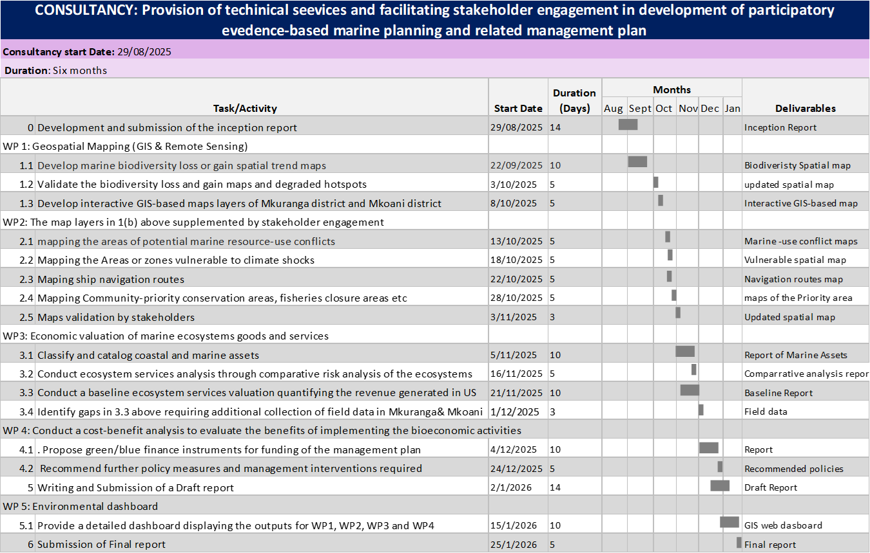

**ANNEX 2: Stakeholder Analysis Report**

This table provides a preliminary analysis of the key stakeholder groups relevant to the MSP process in Mkuranga and Mkoani districts. This analysis will be refined and validated during the initial stakeholder engagement phase.

|  |  |  |  |  |
| --- | --- | --- | --- | --- |
| **Stakeholder Group** | **Key Actors** | **Potential Interests in MSP** | **Influence (H/M/L)** | **Proposed Engagement Strategy** |
| **National Government** | Ministry of Blue Economy & Fisheries, Vice President's Office (Environment), Ministry of Lands | Policy alignment, economic growth targets, national security, meeting international commitments (e.g., 30x30). | H | High-level briefings, representation in a National Steering Committee, formal reporting, policy alignment workshops. |
| **Local Government** | Mkuranga & Mkoani District Councils, Shehia/Ward/Village Leaders | Local revenue generation, land/sea use planning authority, local economic development, political support from constituents. | H | Co-chairing local workshops, regular consultations with District Executive Directors, capacity building on MSP, integration with local plans. |
| **Government Agencies** | TAFIRI, Marine Parks and Reserves Unit (MPRU), Tanzania Ports Authority (TPA), NEMC, COSTECH | Scientific data provision, achieving conservation mandates, regulatory enforcement, infrastructure planning, research permit issuance. | M | Technical working groups, formal data sharing agreements, joint field surveys, regular technical updates. |
| **Local Communities** | Fishers, Beach Management Units (BMUs), Seaweed farmers, Women's groups, Village elders | Livelihood security, continued access to resources, food security, protection of cultural heritage, equitable benefit sharing from Blue Economy. | M | **Primary Focus:** Participatory GIS mapping, focus group discussions (in Swahili), community validation meetings, feedback via BMU leadership. |
| **Private Sector** | Hotel/Tour Operators, Aquaculture Investors, Maritime Shipping Companies, Gas exploration companies | Investment security, operational efficiency, access to resources (e.g., clean water, scenic areas), predictable and transparent regulations. | M | Sector-specific consultations, inclusion in economic valuation and CBA, business roundtables to discuss investment scenarios. |
| **Civil Society / NGOs** | Local and International Conservation & Development NGOs (e.g., WWF, WCS, CARE) | Conservation outcomes, community empowerment, advocacy for sustainable practices, project monitoring and accountability. | M | Collaboration on community engagement activities, sharing of best practices and data, joint advocacy on policy recommendations. |
| **Academic & Research** | Institute of Marine Sciences (IMS), University of Dar es Salaam | Research opportunities, access to new data, student involvement (theses), scientific publications, validation of methodologies. | L | Guest lectures, formal data sharing agreements for academic use, involving post-graduate students in fieldwork where feasible. |

ANNEX 3: Term of References

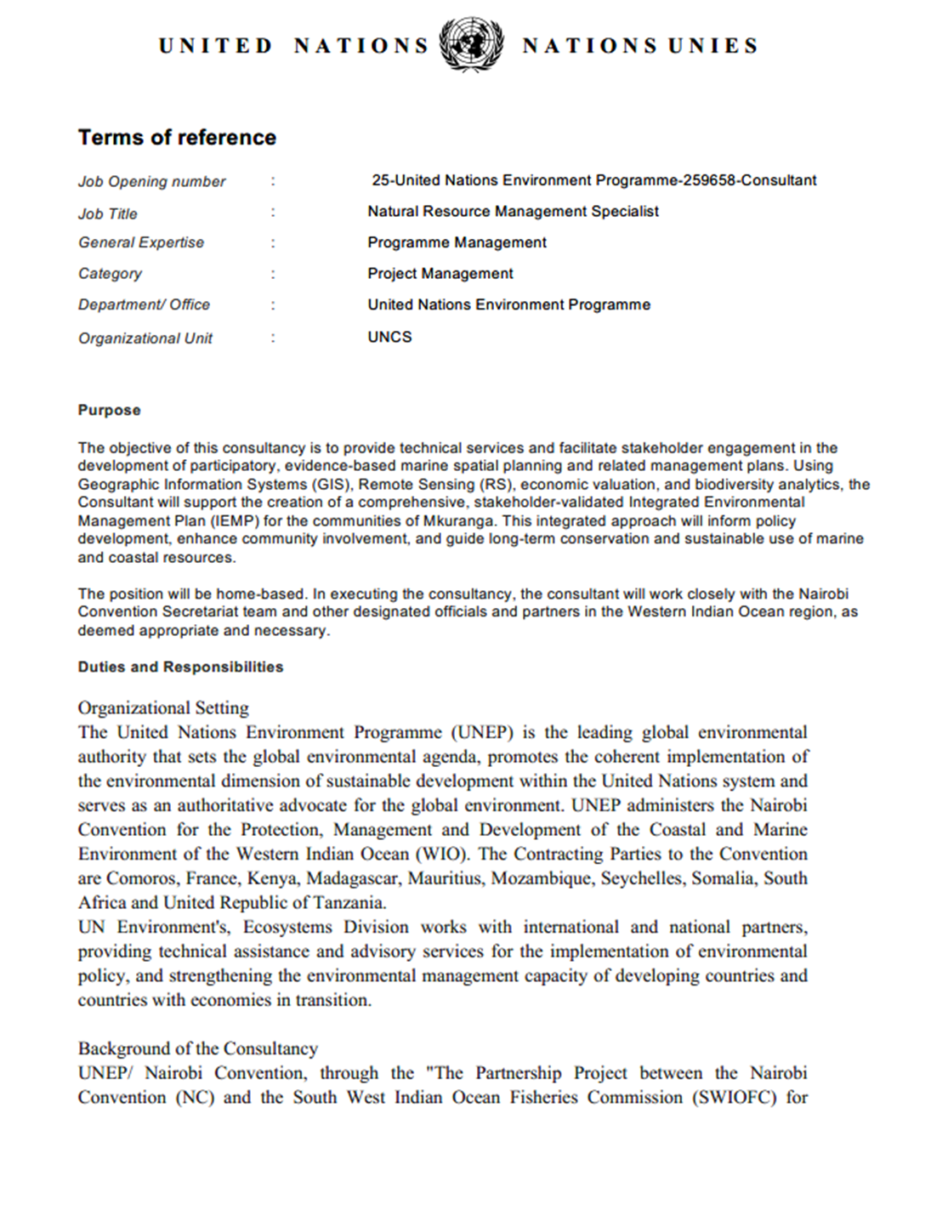

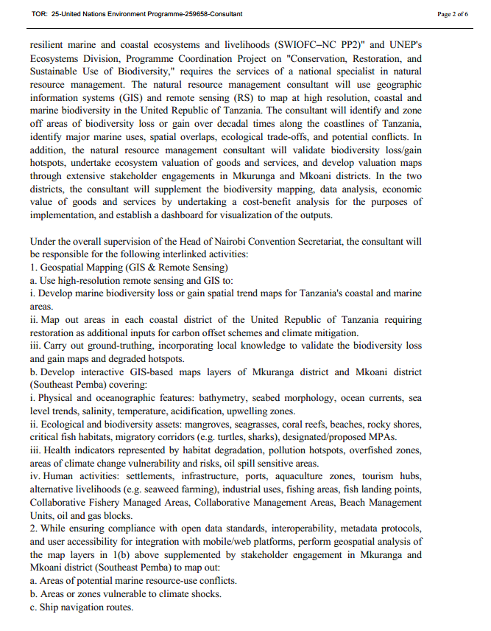

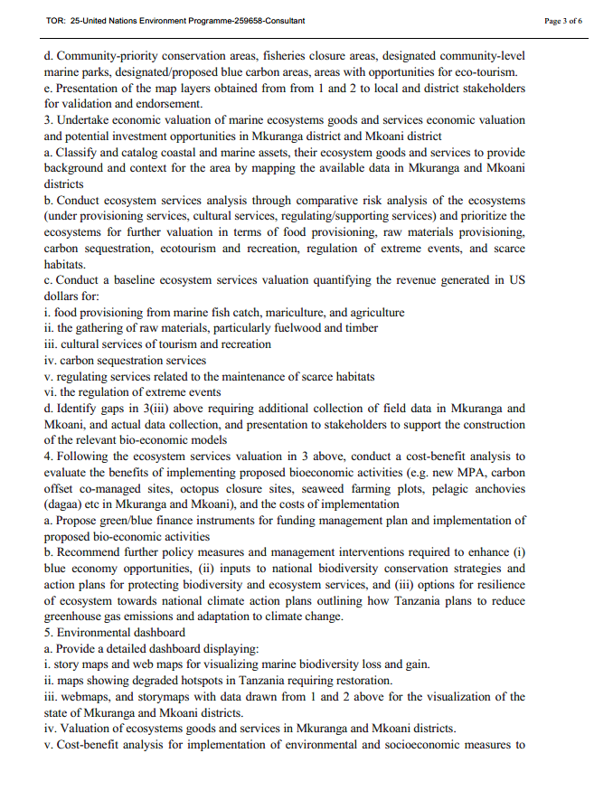

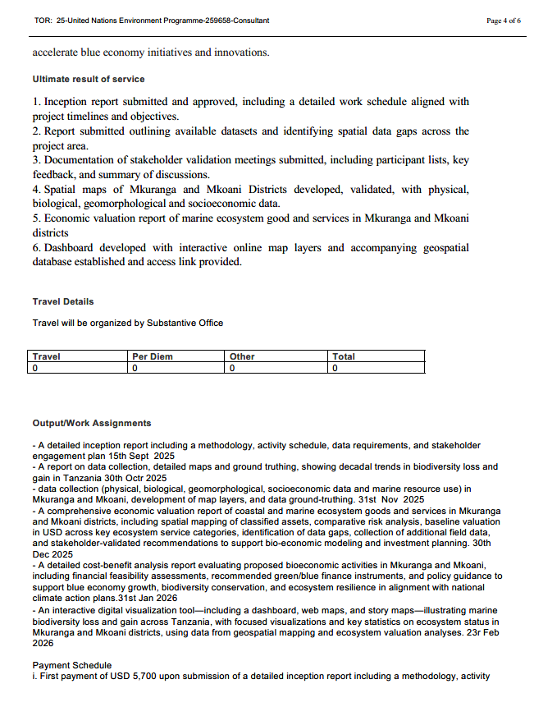

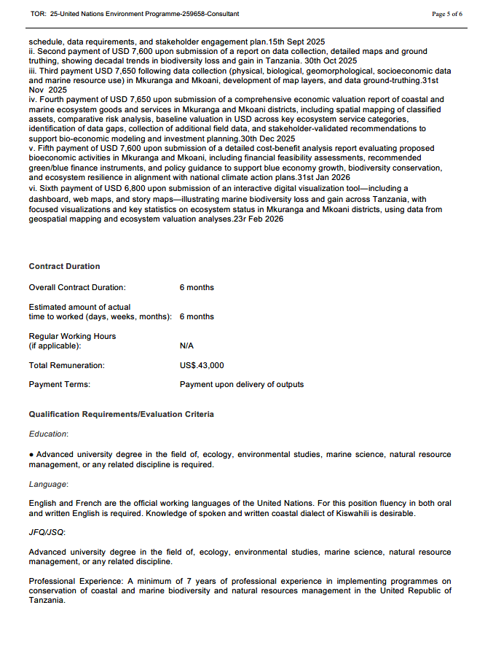

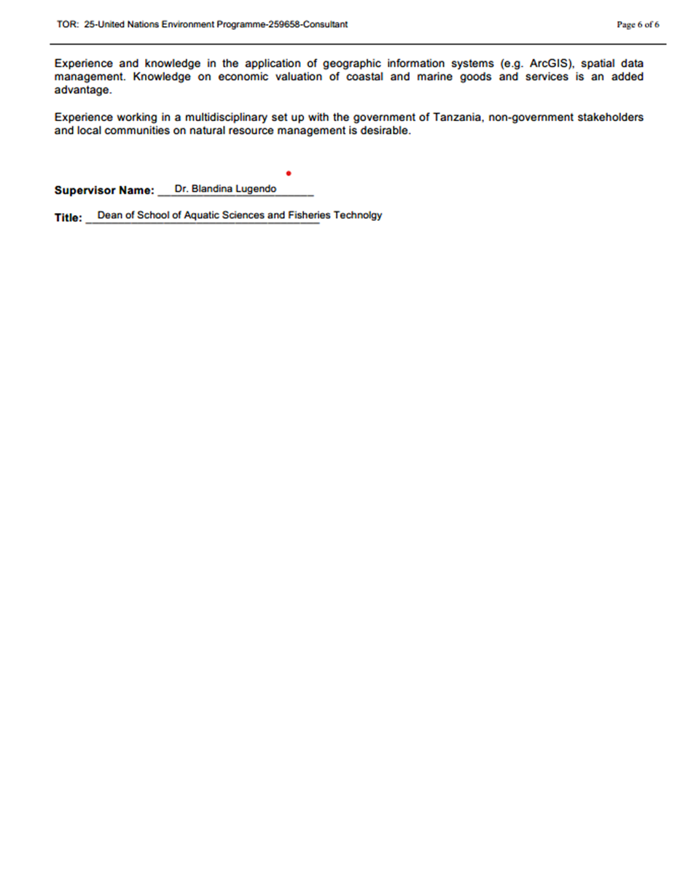

**REFERENCES**

1. Convention on Biological Diversity (2022). Kunming–Montreal Global Biodiversity Framework. CBD COP-15.
2. FAO (2022). The State of World Fisheries and Aquaculture 2022: Towards Blue Transformation. Rome: FAO.
3. Government of Tanzania (2021). *Nationally Determined Contributions (NDC) 2021*. Dodoma: Vice President’s Office.
4. Government of Tanzania (2022). *National Environmental Master Plan for Strategic Interventions (2022–2032)*. Dodoma: Vice President’s Office.
5. IPCC (2021). Sixth Assessment Report: Impacts, Adaptation, and Vulnerability. Intergovernmental Panel on Climate Change.
6. Maina, J. et al. (2016). “Climate change impacts on coral reef ecosystems of the Western Indian Ocean.” Global Change Biology, 22(6), 2750–2765.
7. Marine Parks and Reserves Unit (MPRU). *Strategic Plan 2020–2025*. Ministry of Blue Economy and Fisheries.
8. Mgaya, Y. D. (2016). Fisheries and Marine Ecosystem Services in Tanzania. WIOMSA Book Series No. 7.
9. Ministry of Livestock and Fisheries (2015). *Fisheries Policy*. Dar es Salaam.
10. NEMC (2024). State of the Coast for mainland Tanzania. National Environment Management Council (NEMC). Dodoma, Tanzania. pp. xxxiv + 293p
11. Obura, D. et al. (2019). *The Ocean Transition in the Western Indian Ocean: Sustainable Development Opportunities and Challenges*. Nairobi Convention Report Series.
12. Revolutionary Government of Zanzibar (RGoZ). 2023. State of the Coast for Zanzibar, Zanzibar, Tanzania, xxii + 238pp
13. Richmond, M. D. (Ed.) (2011). A Field Guide to the Seashores of Eastern Africa and the Western Indian Ocean Islands. Sida/WIOMSA.
14. UNEP (2019). Global Environment Outlook 6 (GEO-6): Healthy Planet, Healthy People. United Nations Environment Programme, Nairobi.
15. UNEP-Nairobi Convention Secretariat (2020). Regional State of Coast Report: Western Indian Ocean 2020.
16. UNFCCC (2015). Paris Agreement. United Nations Framework Convention on Climate Change.
17. United Nations (2015). Transforming our world: the 2030 Agenda for Sustainable Development. United Nations, New York.
18. United Nations Convention on the Law of the Sea (UNCLOS), 1982.
19. Western Indian Ocean Marine Science Association (WIOMSA). (2018). *The Blue Economy in the Western Indian Ocean*. WIOMSA Policy Brief.
20. WIOFish Database (2020). *Artisanal Fisheries Data for the Western Indian Ocean*.
21. Zanzibar Planning Commission (2021). *Blue Economy Policy for Zanzibar*. Zanzibar, Tanzania.